Thank you, enkosi, ngiyabonga, dankie
for choosing WebsiteDesign.co.za!

We have put this briefing document together so that your developer can get a better idea of your vision. While content such as text and images are very important, an overall ‘idea’ of the look and feel you like goes a very long way in making sure we create a website that you are proud to show off, and we want you to be proud of your website. When chatting to your developer, please make sure you always include your reference number in the subject line (i.e. WD 1234567). This makes it easier to track everything related to your project.

•••

GUIDELINES ON HOW TO PUT YOUR BRIEF TOGETHER

- Please complete this briefing document as accurately as possible, the more in depth the brief the more we can assist you. Please also double check your spelling & grammar.
- Please make sure you send your completed brief to your developer within 3 days of project activation. (1 day if you booked an express project).
- If you need any assistance with this document, please speak with our friendly sales consultant or your designer without any delay.
- Your developer splits the time available for your development into four parts:

  - 25% Website function and layout,
  - 25% Content, (text, images and video)
  - 25% Cosmetics, tweaking colours and creatives,
  - 25% for reviews.

Every project has a set amount of paid development hours included. You can see this on your quote. If we go over this provision, additional costs will be billed for.

- Once we’ve started your project, your developer will offer frequent updates including a project % status email each Friday with a copy of your project log and a proposed schedule for when your project is booked in the coming new week. Please note: project times are booked in advance and diaries reserved accordingly. Developers/Designers manage several projects in a week, and therefore are not available all hours for any one single project. Please also take note of your project timeline window, this is also detailed on the quote. If this time is exhausted, additional costs will be billed for to extend the timeline.
- Once this project has been completed, we can assist with web marketing, e-security or e-legal services.

•••

Domain & Hosting

(Where your website lives.)

Client’s website and domain need a place to live, this is called hosting. The package you have chosen comes with hosting, emails and a .co.za domain at no price difference.

There are two options:

- If a client has hosting included in their product, you can consider these concerns done and dusted, no doubt our hosting division will be in contact soon, if they have not already done so. Our developer will be able to work with our hosting division to make your site live once ready.

- The other option is a client provides their own external hosting services. In that instance, we zip the website files and provide them to the client to work with their supplier. If your supplier is not helpful, let us know, and we can give you some options.

•••

Structure & Content

(Menu, and your page text)

Depending on your product, you will have different options available to you. We must bear in mind your product limitations when it comes to function, cosmetics and other features. Chat to us to get clarification if needed, but a very good overview of your product scope can be found on the quote you accepted.

Let’s start with menu items and pages. Here we need you to please give us the following information:

- Proposed menu name,
- What the page is about,
- What you will have on each page.

Example:

- Contact page
- The page is about my phone number, email address, map and a digital form
- My phone number, email address, a map to my office, a nice photo of my office and my business registration number.

You can provide these details now by editing this document, please only add information for the amount of pages your product includes.

- Menu items, pages and text

Page 01

- Menu name: Home
- What is this page about?: This page provide high-level information about the company
- What will you have on this page?:

You can copy your page text below:

Page header to have a gold(as per company colours) underline.
Background image: Background pillar

Header Gif – Banner at top

Moshate Consulting is an ICT and Management Consulting firm focused on innovative business management and digital solution services. We create tailored solutions that drive long-term value for our clients empowering them to achieve sustainable growth. Trust us to be your partner in success.

Header text: Under About

“Moshate partners with organisation small and large to collaborate and co-create fit-for-purpose solutions to deliver value to all stakeholders involved. The use of digital technology tools and leading practices to solve business problems is critical to our delivery capability.

Moshate Consulting is 100% woman owned and with Level 1 BBBEE status.”

Why Us
​
Our value proposition is centered on harnessing our organization’s capabilities to drive excellence. We focus on innovative ideas and unmatched delivery capacity to ensure that we exceed expectations and deliver outstanding results. By prioritizing creativity and efficiency, we empower our clients to achieve their goals successfully.

Next Section

What we do

We help clients ideate and implement tailored solutions to deliver value to their customers and stakeholders for long term impact.

Use icons similar icons – icons must be in gold. A link on icon must be made available for user to click to navigate to Services page.

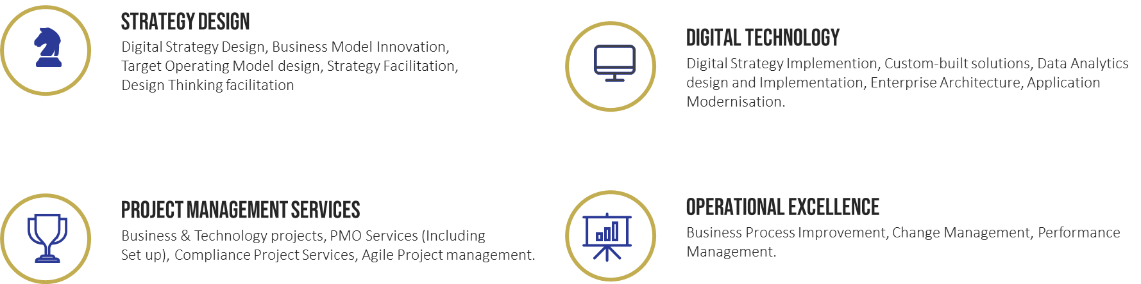

Next section

Our Services are designed for small and large organisation. We understand the trends, leading practices and the industries in which we operate to ensure that services and solutions deliver high value to clients and the ecosystem they operate in.

GIF: Picture 2

Picture: Banner at the bottom

Tag line:

Streamline.Simplify.Sustain

Page 02

- Menu name: About Us

You can copy your page text below:

Page header to have a gold(as per company colours) underline.

Banner text:
Moshate Consulting Services is a leading IT consulting firm specialising in delivering innovative ICT and management solutions. Our dedicated team focuses on driving long-term value for our clients through strategic digital services and business management expertise. With a commitment to excellence and innovation, we tailor our solutions to meet the unique needs and goals of each client, ensuring sustainable growth and success.
Banner gif: Main Header picture

Our story

Our mission is to empower businesses with the tools and strategies needed to thrive in today's fast-paced digital landscape. By combining technical expertise with industry insights, we help organizations harness the power of technology to achieve their objectives and stay ahead of the competition.

Our company is founded on values of honesty, excellence and respect. Ubuntu drives our company culture in that we are because of our client. We believe in providing the best value to our clients by utilizing highly skilled teams that will drive excellence, high performance, and quality in the services we offer.

Moshate partners with organisation small and large to collaborate and co-create fit-for-purpose solutions to deliver value to all stakeholders involved. The use of digital technology tools and leading practices to solve business problems is critical to our delivery capability.

We are passionate about public service and have experience in multiple industry within the public sector including Revenue Management, Public Safety, Education and Public Service Operation.

Have combined experience across Information Technology, Mining, Banking & Insurance, Telecommunication and Health within the private sector.

Picture – Body 1 & 2

Next section
DELIVERY APPROACH

Our delivery is based on these four core principles:

Our delivery approach is founded on four core principles: Collaboration, Agility, Client focus, and Digital Mindset. We believe that teamwork drives innovation, and our agility helps us respond to evolving needs. By prioritizing our clients in every aspect of our work, we ensure our solutions are customized to their specific requirements. Adopting a digital mindset allows us to harness cutting-edge technologies for the best possible outcomes.

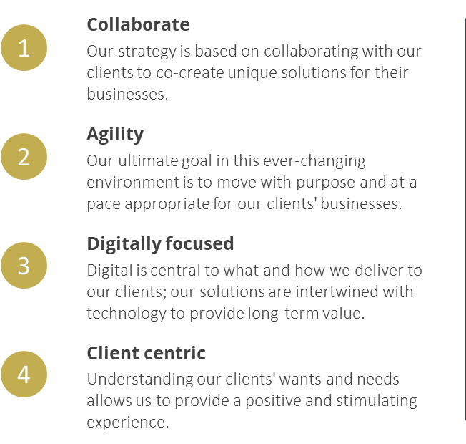

Page 03

- Menu name: Services
- What is this page about?: This page lists the services were provide as a company
- What will you have on this page?:

You can copy your page text below:

Page header to have a gold(as per company colours) underline.
Page should include background pic – Background pic

Picture to be put on to

Image BANNER 1 – Consulting Services

Moshate Consulting Services offers cutting-edge ICT and management solutions to enhance your business operations. Our strategic digital services and expertise in business management are tailored to drive lasting value for your organization.

Strategy Design
Image name 2: Strategy design
Strategy in Action
Our strategy design consulting services empower businesses to strategise and plan ensuring they are well-positioned for the future. We collaborate closely with organisations to develop tailored strategies that drive growth and resilience in an ever-evolving marketplace. Our services include:
- Digital Business Strategy Design & Planning
- Strategy Facilitation
- Organisational Design
- Target Operating Model Design
- Business Model Innovation
- Design Thinking Facilitation

Digital Transformation
Image name 3: Digital Design
From digital strategy development to implementation, we help businesses adapt to the evolving digital landscape and stay ahead of the curve. With our extensive expertise, we offer tailored advisory, guidance and implementation of digital solutions that are perfectly suited to enhance your business operations. Let us help you optimize your processes and embrace the opportunities that digital transformation brings. Services include
- Digital Strategy implementation
- System integration services
- Adaptive Enterprise architecture
- Data analytics design & implementation
- Application Modernisation

Project Management & Delivery Services
Image name 04: High Performance Delivery
Unlock the potential of your organization with our comprehensive services designed to bring your strategic initiatives to life. We specialize in establishing Project Management (PMOs) to ensure consistent project delivery, alongside managing compliance-related projects such as POPIA and business continuity. Our offerings also include Agile Project Management and Project & Portfolio Management Implementation, all aimed at delivering quality and dependable outcomes that add value to your organization and its ecosystem. Let us help drive success and efficiency across your projects.
- PMO Services (which includes set up and operationalization)
- Agile Project management
- Project & Portfolio Management Implementation

Operational Excellence
Image name 05: Operational excellence

Elevate your business with our Operational Excellence services, designed to enhance your business operations and drive superior performance. We focus on stream workflows, reducing inefficiencies, and improving service delivery through the following:
- Business Process Redesign & automation
- Change Management
- Performance management
- Policy review & implementation

Next section

Resources
Image name: Next section - IT Resources
MCS brings years of expertise in the Information Technology industry, to support your critical IT and business projects. With a robust database of skilled professionals, Moshate has successfully collaborated with clients to deliver key projects, ensuring you have the talent to meet your needs.
Footer banner:
Image name: Footer banner
Page 04

- Menu name: Contact Us
- What is this page about?: The page is about my phone number, email address and a digital form for the visitor to send an enquiry or message
- What will you have on this page?:

You can copy your page text below:

Get in Touch

Get in touch with us by sending us a message using this form or email us at admin@moshateconsulting.co.za and we will get back to you shortly.

Banner Image 1: Banner Image

Footer image 2: Contact us footer

Page 05

- Menu name: Blog/Article
- What is this page about?: This page is for providing information on different topics by the executives.
- What will you have on this page?:

You can copy your page text below:

Hide tab for now.

Need more pages?
No problem! Create a new MS word page of the table, edit the page names, and cut and paste back into this master document.

•••

Contact form

(Contact us)

Which page / pages do you want your contact form on?
Page 4

What text based responses do you need? (name / email address / contact number etc)

Name
Email Address
Contact number
Message

Do you want any drop down responses? (ie City, reason for enquiry / etc)

Province

Do you want a section where clients can add additional notes?

No

Captcha / reCaptcha (verification when completing a form (please send us your Google Business detail):
Yes

Would you like an “I agree to the T’s & C’s” tick box? This would need to have a link to your T’s & C’s.
Yes – see below
https://www.termsfeed.com/live/80378e5f-4300-457e-a562-0bb236410617

https://www.termsfeed.com/live/d13002d7-115e-4f5c-8440-170e9efeb0d7

•••

Images

(Logo, page and gallery images.)

Your images need to be in a ready to use state, and named according their relevance. This content can be uploaded to your DropBox / GoogleDrive / WeTransfer account and the link can be copied below. For primary images such as banners or logo, try ensure the file size is between 200-300kb, and for standard page images or your gallery photos, ensure the file size is around 50kb-80kb. Image file size is very important, and can slow down a website. File formats we accept are jpeg and png.

Please make sure each image has a unique file name, and the name needs to be relevant to the content of the page.

Below is an example of how to set the image folders up so there is no confusion as to what needs to go where.

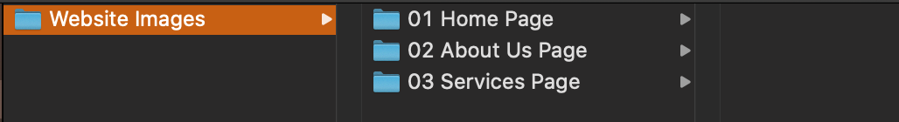

Below are some links to image resources. Please do not save images using image searches / search engines etc. Without the correct certificate/license you can be fined. The options below offer you licensing. When downloading please remember to save each license and make sure it stipulates you can use it for commercial purposes -
- FreePik - https://www.freepik.com/ - they have a nice selection and their pricing structure is not bad at all.
- Shutterstock - https://www.shutterstock.com/ - great selection, but on the pricier side.
- Pixels - https://www.pexels.com/ - not the widest selection, but free source.
- Unsplash - https://unsplash.com/ - not the widest selection, but free source.

•••

Look & Feel

(Templates, colour scheme and fonts)

- Now that we’ve finished up with your content, we want to know how you’d like your website to look. Below are your template options for your CMS BUSINESS website.

We use Divi library for our layout choices. You can select a layout you like from there and just advise the theme name.

**Please note functionality remains the same regardless of framework choice. For the templates, you are looking at the layout only – colours, fonts and images are all dictated by you. If you require extra functionality, it needs to be confirmed at time of sale.

Divi theme library: https://www.elegantthemes.com/layouts/

Corporate div layout pack
Corporate Home - Elegant Themes

- Considering your website colour scheme. A good reference for a Colour Scheme can be found at https://colorhunt.co/. You can screenshot the colours you like below, or give us the hex codes if you have them (i.e: #7CD1B8). If you have existing documents or a logo that you’d like us to use the colours from – then you can send this along to your developer instead and make a note within the brief.

Colours:

As per our corporate ppt. template

RoadMap & Planning

- Fonts.

It is always better to choose a Google font, Google fonts are the most widely used fonts across websites meaning that the compatibility rate across devices and browsers is highest.

Font options can be viewed at https://fonts.google.com/

Please add your font options below.

Header font: (This is the main heading at the top of the page.)

As per layout

Title font: (This is the font used for paragraph titles.)

Bebas Neue

Body font: (This is the font used for the text paragraphs on your website pages.)

Calibri light

Footer font: (This font is used for the strip at the bottom of each web page.)

Calibri light

•••

Legalities

(T’s & C’s and legislation.)

Your website lives in a public realm and there are rules that govern it as well as the content you post. Many people are fined and prosecuted for not taking reasonable steps in managing their websites. As part of our client care, we want to share some important points for consideration. You can book an advance consult to discuss legalities on the web if you need.

- Add to your website Terms and Conditions / Privacy and Usage Policy. These links might be useful: https://app.termsfeed.com/wizard/terms-conditions and https://app.termsfeed.com/wizard/privacy-policy

- Your website needs to be POPIA compliant (Protection of Personal Information Act). You can find information on this as well as usage policies on our Client Zone at https://www.websitedesign.co.za/pdf/POPI-act.pdf

- Copyright. Images, text, sounds, images, basically any work of art or creative can be subject to copyright protection or other related legislation. This is not a matter to be overlooked and can involve criminal prosecution in some cases.

If you are uncertain of any of the above points of consideration, chat to us now. You can provide text for you Terms and Conditions / Privacy and Usage Policy or even Popi notice for your site in the space provided for below with an instruction for your developer on where you would like it added to your website.

•••

Web Marketing

(How will people find your business online?)

Once your website has been completed and it is live – how will you draw visitors there? Ranking on search engines is extremely competitive. You are competing against hundreds and thousands (and in many cases – millions) of other websites that have been there a lot longer than yours. And ontop of that – new websites are launched on a daily bases.

There are many things you can do yourself such as linking your social media to your website. Including your website URL in every social media post. Adding videos to YouTube to draw people to your site. Updating your content on a regular basis – a blog page on your site is an extremely useful tool for this.

But this is only one side of your marketing. To increase chances of higher rankings there are tools such as SEO, Adwords or even marketing consults with an expert.

Please have a look at some of the ways we can help you but following the links below:

SEO: https://www.websitedesign.co.za/websitedesignmarketing-seo.html
Adwords / PPC: https://www.websitedesign.co.za/websitedesignmarketing-adwords.html
QR codes: https://www.websitedesign.co.za/qrcodes.html

•••

CONGRATULATIONS!

If you’ve completed all of the above steps – we can now start to build the first preview of your website.

We look forward to completing a website that you can be proud of.

•••

